**Problem Statement (AM-2)**

**Problem:**

Currently, for roof top rain water harvesting, people install water storage tanks individually per building/apartment which results in high cost for individuals/groups.

***Research Gap:***

*No mechanism/application is available to find out where such installations are beneficial, which installations can share storage tanks and what would be the required capacity of these shared tanks.*

*Given map and housing data, optimize the location of centralized tanks for rain-water harvesting.The following data should be sufficient to design and implement a model to solve the problem:*

1. **Estimating rainwater harvesting capacity:** 
   1. **Rainfall estimation:**

* LSTM based prediction model
  1. **Catchment area:**
* Master plan of the city to estimate the catchment area available, e.g open areas like rooftop, courtyard, etc.
* Using Canny edge detection and color filtering

1. **Optimizing Water tank placement:** 
   1. **Water demand/Use capacity:**

* Water supply data has been used to estimate the consumption of harvested rainwater
  1. **Underground map:** Underground map with **stability study** to **identify** **locations** where the **shared tank** can be built. The system should provide the following output from its analysis:
     1. **Plan for laying out the underground tanks with input and output points defined**

Could not be completed

* + 1. **Cost-benefit analysis justifying the plan**

Used yield after spillage (YAS) algorithm:

* To calculate the optimal size of the tank,
* To find the break-even point

**3. Plan for distribution of build and maintenance cost of a tank for the parties involved**

**Who will invest (Upfront Capital Investment)**

* Real Estate Companies in their housing project, or
* Municipality

**How to sustain (Maintenance Cost)**

* Recovered from user/households in the form of monthly rental /society maintenance charge.

**Why to invest (Motivation)**

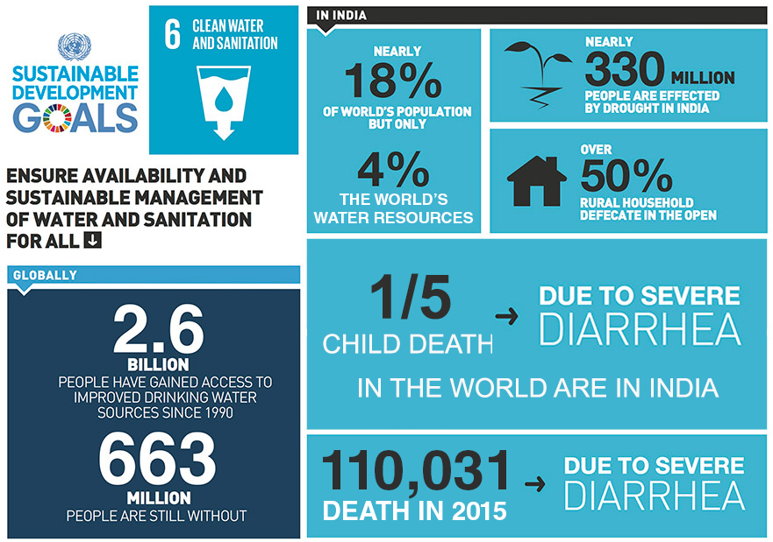

Fig: Sustainable Development Goals-6, Water and Sanitation for all, UNGA 2015

(Source: http://in.one.un.org/page/sustainable-development-goals/sdg-6/)

Economical Motivation

* India has nearly 18% world population but has access to only 4% of the world’s water resources
* As a growing economy it presents a huge market for providing water resources and water management services to the population
* Rain water harvesting market is growing at the rate of 6.56% annualy, in 2016 it is at $100 Million and expected to be at $137.40 Million by 2021.

Ecological Motivation

* Rainwater harvesting has a direct positive impact on the environment:
* reduces municipal water use
* average household is using 18% of their water for flushing the toilet and 23% for the washing machine!
* Alternative to the supplies from reservoirs or groundwater
* helps manage storm water run-off to prevent erosion, flooding and poor water quality in our lakes an streams.
* able to reduce municipal water demand enough that
* Municipal can expands their service base
* large new public water sourcing projects become unnecessary
* In urban areas, 90% runs off because of sealed surface due to concretion
* Infrastructure projects to increase water supply use massive amounts of energy and natural resources in addition to the obvious cost to ratepayers. Rainwater harvesting and utilization helps minimize the need for these projects.
* Municipal water treatment and pumping make up a high percentage of energy and chemicals. Rainwater systems reduce this usage.

Social Motivation:

* Sufficient supply of pure drinking water ensure better health of individuals
* Help in reducing cases like diarrhea

**Future Scope:**

* Improving efficiency of Catchment Area Estimation
* Improving efficiency of Clustering algorithm for optimal tank setup
* Using individual smart water metering along with an app based solution could be used to keep track of water consumption and accordingly the slabs could be designed and users be charged as per their usability.